PRESS RELEASE
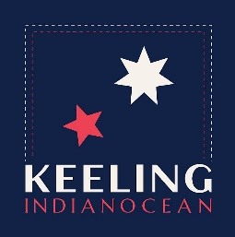
KEELING is a visionary brand aiming to a healthy Ocean. KEELING Spring-Summer 2023 collection is created by the multinational company Sealand International with the aim to supply sealife gears to ocean lovers. The Ocean is the foundation of all life, an extraordinary environment populated by incredibly diverse faunas and floras. The Ocean shapes our planet. The Ocean connect the people. KEELING means Ocean.
Leisure sportswear, beachwear and swimwear products are generated by unique design and manufactured all around the world with sustainable recycled materials. KEELING beachwear brand express the stunning colors of Indian Ocean. The pure beauty and strength of nature paint the KEELING Spring-Summer collection 2023, the absolute debut of this multinational initiative born in the United Arab Emirates by the partnership of Italian, Chinese, Australian, American. The ocean lives in KEELING through the corals, the shores, skies and fruits.
KEELING’s efforts for a sustainable manufacturing industry make the brand start as one of the most stimulating ocean conservation players in the fashion world. KEELING puts the Ocean at the heart of its mission by introducing also CLEAN COLOR, our revolutionary sustainable textile dyeing technology, which significantly reduces use of water to preserve oceans and allows the colour essences to irregularly penetrate the fibers while lending a crinkle aspect to the surface making every item unique.

